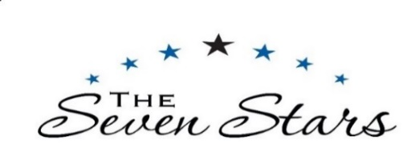
LIGHTER BITES…
Monday - Saturday Lunchtimes 12 – 2pm

Star Ploughman’s – red onion chutney / dressed mixed salad / pickled onions / frozen grapes / fresh bread (gfa) 13
please choose 2 – Ham / Cheddar / Brie / Stilton
Honey & Mustard Glazed Wiltshire Ham / fried free-range egg / triple cooked chips / mixed salad (gf)
Large 17 / Small 13
Cider Battered Haddock / triple cooked chips / garden peas (gf)
Large 19 / small 13.5
Breaded Scampi / skin on fries / garden peas
Large 17 / small 13

SALADS –
Small Smoked Salmon Salad Nicoise / green beans / new potatoes / olives / tomatoes /
mixed leaves / soft boiled egg / lemon, dill & caper dressing (gf) 14.50
Small Burrito Bowl – black beans / quinoa / red onion / sweetcorn / avocado / nachos / peppers / lime (vg gf) 12.50
add a topping - chilli beef 3

FLATBREADS –
Chicken Ceasar Salad 14
toasted flatbread / smoked bacon / gem / parmesan / anchovies / Caesar dressing
Sundried Tomato, Olive & Halloumi (v) 13.5
toasted flatbread / tomato, cucumber & red onion salad / honey, mustard dressing
add: skin on fries (vga gf) 4.5 / triple cooked chips (vga gf) 5.5

PANINIS -
Bacon & Brie 10.5
Cheddar & Red Onion (v) 8.5
add: Ham for 1.5
Tuna, Cheddar & Red Onion 10

A DISCRETIONARY SERVICE CHARGE OF 10% WILL BE ADDED OF PARTIES OF 6 OR MORE
Our dishes are prepared within our kitchen and cooked fresh to order, at busy times your food may take a little longer to reach you so we may not be able to make changes to your dishes.
We have strict procedures when preparing allergen dishes, but we cannot guarantee any of our dishes are 100% free of allergens. Please speak to a manager on duty.
v = vegetarian / vga = vegan available / vg = vegan / df = dairy free / gf = gluten free / gfa = gluten free available

